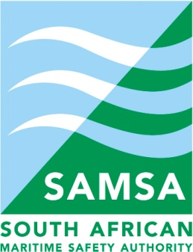

ACTION ITEMS

2015/2016 1ST QUARTER PORT CONSULTATIVE COMMITTEE: PORT OF SALDANHA
10:00 FRIDAY, 17 JULY 2015
PCC ACTION ITEMS
# | ACTION ITEM | DETAIL | BY WHEN | WHO
1. | Bi-Lateral Agreements | Department of International Relations – DIRCO: Presentation. DIRCO to provide overview on South Africa’s agreement with other African trading countries as it relates to visas etc. | Ongoing | DOT
2. | Private Sector Participation Framework (PSP) | A request to be forwarded again for the presentation to be made to the PCC members. The Secretariat to facilitate. | Prior to the 2nd Quarter 2015/16 | Secretariat/DTI/DPE/DOT
3. | Utilization / supply of electricity of electricity | TNPA not in a position to provide capacity schedule for water and electricity as the land use plan still in process. Update will be given at the next PCC meeting. | 2nd Quarter2015/16 PCC meeting | TNPA
4. | IMDG Training Update | IMO confirmed that due to financial constraints, the IMDG training will only take place in KZN region during September 2015.  DOT has confirmed that UN Dangerous Goods training will however be provided on a regional basis once service provider has been sourced. Dates and venues will be circulated once all logistics has been confirmed. | Ongoing | DOT/Secretariat
5. | Iron Ore Dust and Corrosion Effect of Iron Ore | Presentation was given regarding the results of the Iron Ore Dust testing however the corrosion effect of iron ore was not included in the study.  A formal complaint has been received from a Port User regarding the iron ore dust and corrosion effects of iron ore. Once all documentation including proof of evidence has been received from the complainant, the matter will be formally escalated and dealt with in accordance to the PCC process. | 2nd Quarter 2015/16 | TPT/Port User/Secretariat

