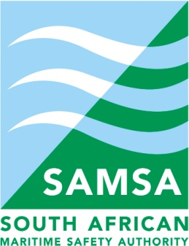

ACTION ITEMS

2015/16 1ST QUARTER PORT CONSULTATIVE COMMITTEE: PORT OF MOSSEL BAY

09:00 MONDAY, 20 JULY 2015
PCC ACTION ITEMS
# | ACTION ITEM | DETAIL | BY WHEN | WHO
1. | TNPA/PETROSA Engagement | An invitation will again be forwarded to PetroSA to make a presentation with regards to Project Ikhwezi and how it would impact the Port of Mossel Bay and surrounding areas. | Prior to 2nd Quarter 2015/16 PCC meeting | Secretariat
2. | Port User: Tourism / Leisure / Cruise Liners feedback | Invitation will be forwarded to the Tourism / Leisure / Cruise liner constituency to do a presentation.  New Election nomination process to follow to nominate and elect an alternate. | 2nd Quarter 2015/16 PCC meeting | Port User: Tourism / Leisure / Cruise Liners
3. | Status of Mossel Bay as a Port of Entry | This matter is part of the Operation Phakisa and it affects the Ports of Mossel Bay, Cape Town and Saldanha.  The Chairperson will provide feedback by the 2nd week of August 2015 and also suggested that Department of Home Affairs be invited to the next PCC meeting to do presentation regarding progress in this matter. | 2nd week August 2015 | Chairperson
4. | Labour Guidelines Workshop | National Office bearers for UNTU and SATAWU to be approached with dates for discussion regarding the drafting of the Labour Guidelines.  . | Prior to 2nd Quarter 2015/16 PCC meeting | Labour
5. | DOT – IMDG Training | IMO has confirmed that the IMDG training to only take place KZN region during September 2015. UN Dangerous Goods training dates will be confirmed by DOT and communicated to all. | Update as and when information is available | DOT/Secretariat
6. | Non-attendance of Industry at PCC meetings | Nomination and election process in process of being finalised. | Prior to 2nd Quarter 2015/16 PCC Meeting | Secretariat

